

**Term-Paper of Linux**

**Linux as a Personal Desktop Operating System**



**Submit To**

**Pallvi Arora**

**Linux**

|  |  |  |
| --- | --- | --- |
| **PREPARED BY** | | |
| **STUDENT’S NAME** | **ROLL NUMBER** | **REGISTRATION NO.** |
| EKHLAKH AHMAD | RD2215B67 | 12209166 |

Lovely Professional University, Punjab(India)

**Table of Contents**

1. LINUX IS A PERSONAL DESKTOP: 3

1.1. Abstract: - 3

1.2. Introduction: - 3

1.3. Linux Distribution: - 3

1.4. Desktop environments: - 4

1.5. History of Desktop Linux: - 4

1.6. Feature of Linux: - 5

1.7. File system Basics: - 5

2. How is the Linux OS used as a personal desktop? 7

3. Reason Why Linux is Better than Windows? 8

# LINUX IS A PERSONAL DESKTOP:

## Abstract: -

Desktop Linux, also called Linux on the desktop, refers to specialized Linux distributions with features designed for desktop personal computer users.

Just like Windows XP, Windows 7, Windows 8, and Mac OS X, Linux is an operating system. An operating system is software that manages all of the hardware resources associated with your desktop or laptop.

## Introduction: -

Linux is a just like Windows, IOS, and MAC OS, Linux is an operating system. One of the most popular platforms on the planet, Android, is powered by the Linux operating system. An operating system is software that manages all of the hardware resources associated with your desktop or laptop. The operating system manages the communication between your software and your hardware. Without operating system (OS) the software wouldn’t function.

## Linux Distribution: -

Linux has a number of different versions to suit any type of user. These versions are called distributions. Nearly every distribution of Linux can be downloaded for free. Each distributions have a different take on the desktop.

Popular Linux distributions:

* LINUX MINT
* MANJARO
* DEBIAN
* SOLUS
* KALI
* FEDORA
* UBUNTU
* ANTERGOA

## Desktop environments: -

* KDE desktop environment Linux offers many desktop alternatives.
* The most popular desktop environments are GNOME, KDE and Xfce.
* These environments present a GUI using a desktop metaphor.
* All of these environments allow the user to set many personal preferences and to perform common system managements tasks.
* All Linux desktop applications use the X Window System and thus benefit form features like networking (remote display) and quick mouse-only, cut, copy, and paste.
* Mouse selected text is automatically copied, and it can then be pasted using a middle click, without the need to resort to use the keyboard.
* Desktop Linux environments have been improving in appearance and overall integration over time.
* This has led to wider adoption of the platform over time.

## History of Desktop Linux: -

* Linux began in 1991 as a personal project by Finish St. Linus Torvalds.
* The Linux kernel is publicly announced on 25 August by the 21 years old Finnish student Linux Benedict Torvalds.
* Version 0.01 is released publicly on 17 September.
* The Linux kernel is relicensed under the GNU GPL in 1992.
* The first Linux distributions are created in 1993.
* Over 100 developers work on the Linux kernel in 1993.

## Feature of Linux: -

* Linux is a free and open-source Operating system.
* Its source code is available for everyone to modify for both commercial and non-commercial uses.
* Shell/command-line Interface.
* End-to-end encryption.
* Graphical User Interface(GUI).
* Configure keyboards is different languages.
* Frequent New Updates.
* Extremely flexible.
* Best For Developers.

## File system Basics: -

* A file system is a logical collection of files on a partition or disk.
* A partition is a container for information and can span an entire hard drive if desired.
* One file system per partition allows for the logical maintenance and management of differing file systems.
* Everything in Linux/Unix is considered to be a file, including physical devices such as DVD-ROMs, USB devices, and floppy drives.
* The directories have specific purposes and generally hold the same types of information for easily locating files.
* A file system is an architecture defining how files are stored and retrieved.
* File system are defined based on where they are used.
* There are file systems defined for operating systems, networks, databases, and other special-purpose file system.
* When talking about on OS, a file system may be defined as a hard disk, flash memory, RAM, or optical discs.

|  |  |  |
| --- | --- | --- |
| 1. | / | This is the root directory which should contain only the directories needed at the top level of the file structure. |
| 2. | /bin | This is where the executable files are located. These files are available to all users. |
| 3. | /dev | These are device drivers. |
| 4. | /etc | Supervisor directory commands, configuration files, disk configuration files, valid user lists, groups, ethernet, hosts, where to send critical messages |
| 5. | /boot | Contains files for booting the system. |
| 6. | /home | Contains the home directory for users and other accounts |
| 7. | /mnt | Used to mount other temporary file systems, such as cdrom and floppy for the CD-ROM drive and floppy diskette drive, respectively. |
| 8. | /kernel | Contains kernel files. |

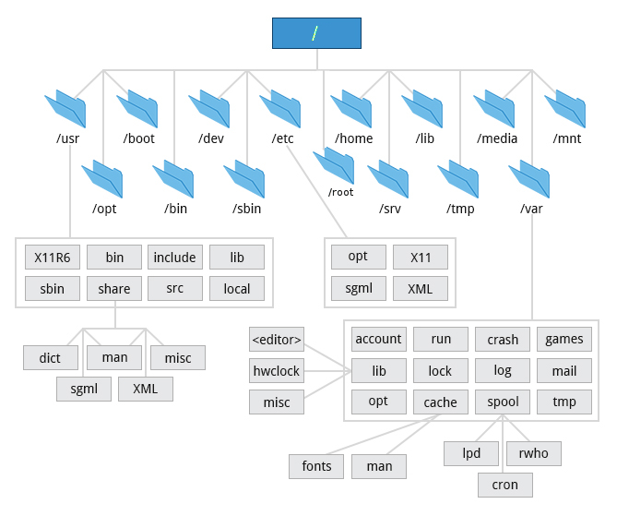

# How is the Linux OS used as a personal desktop?

Every version of the Linux OS manages hardware resources, launches and handles applications, and provides some form of user interface.

Linux version is available for almost any task, and Linux has penetrated many areas of computing.

**For Example,** Linux has emerged as a popular OS for Web servers such as Apache, as well as for network operations, scientific computing tasks that require huge compute cluster, running databases, desktop and endpoint computing, and running mobile devices with OS versions like Android.

The Linux Operating System can be found in many different settings, supporting many different use cases.

**Linux is used in the following ways:**

* Server Operating System: -
* Desktop Operating System: -
* Headless server Operating System: -
* Embedded device or application Operating System: -
* Network Operating System: -
* Software development Operating System: -
* 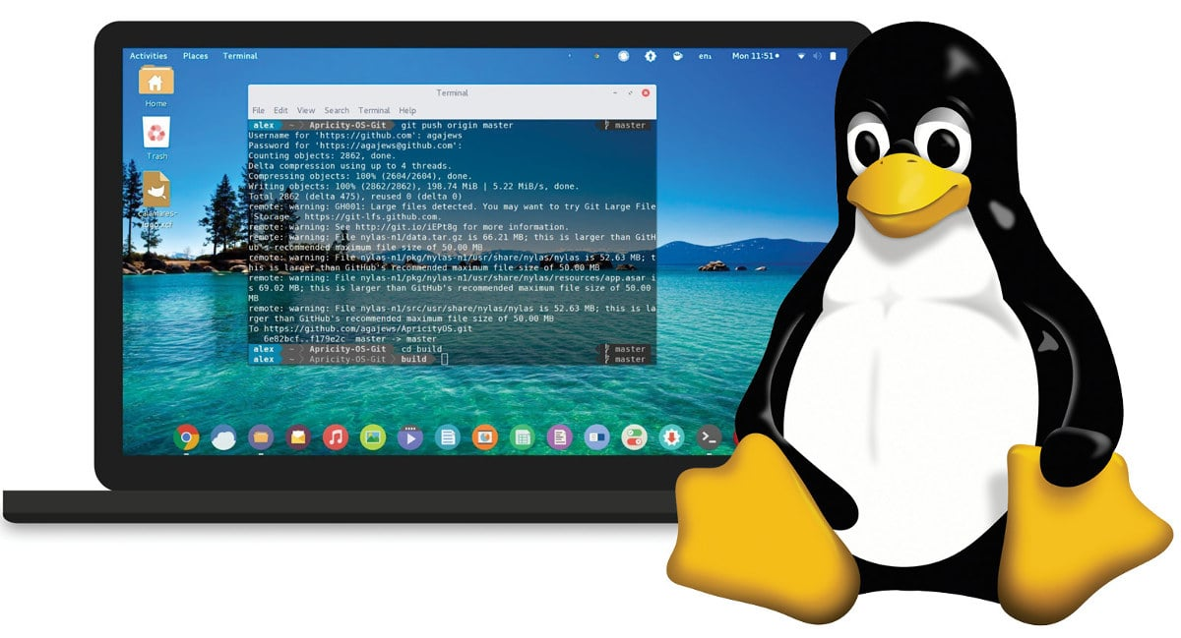Cloud Operating System: -

# Reason Why Linux is Better than Windows?

First, Linux is far more secure than Windows or macOS for that matter.

Linux software is almost always free. LibreOffice, for example, is every bit as good as Microsoft Office and won’t cost you a penny. Sure, there are some programs Adobe Photoshop, that can’t easily be replaced on Linux thanks to its third-party software ecosystem. But, if all you need is basic image manipulation, Gimp will serve you well and it’s also free.

* Open-Source Nature.
* Secure.
* Can revive older computers.
* Perfect for Programmers.
* Software Updates.
* Customization.
* Variety of distributions.
* Free to use.
* Better Community Support.
* Reliability.
* 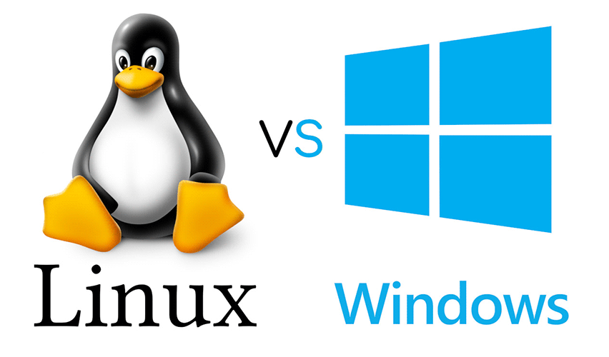Privacy.